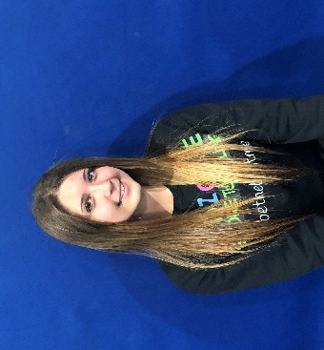 COACH RAINA HANSON, Tumbling classes, Ninja Kidz, Birthday Parties
I am 15 and currently a student at Southern Regional High School. I have always enjoyed & played a variety of sports including field hockey, softball, basketball, soccer, dance, and gymnastics. I did gymnastics for many years and am excited to pass on my love of the sport to the students at Kidzone. I enjoy spending my free time with family & friends doing anything, but especially outdoor activities.
I hope to help my students succeed and excel in their tumbling skills. I am a dedicated coach with a positive attitude, good work ethic, and want the students in my classes to feel increased self-confidence and proud of their accomplishments.

