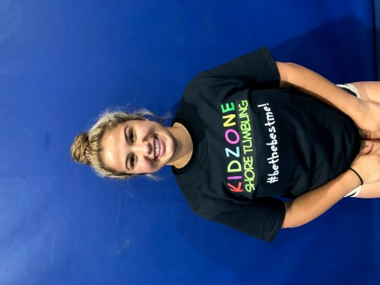 COACH FRANKI DISANZO
Hello I am happy to say that I am a Tumbling Coach at Kidzone. I love forming a connection with the kids and helping them reach their tumbling goals. I am a cheerleader and gymnast myself and when I achieve a new tumbling goal or even master one I’ve been working on, it makes me so happy. And I love that I have the opportunity to pass this knowledge onto my students.

