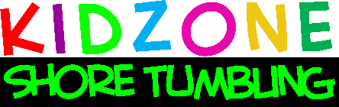
3/16/2020
Dear Kidzone Families,
In response to today's CDC requirement of all gyms to be closed by 8pm tonight we wanted to communicate with you that we will be cancelling all classes, activities & events effective immediately. The restriction is until further notice so we will be monitoring carefully to ensure our decisions are prudent and compliant with governmental recommendations.
- We will be honoring make-up classes for all families who will be missing classes due to this health crises.
- We will not process any auto charges for monthly tuition packages unless we are scheduled to re-open.
- Birthday party deposits will be held for re-scheduling.
We feel so strongly that it is so important to keep our children active and in a productive routine, and without school as an outlet, physical activity is even more imperative for their physical & mental health. Please find creative ways to keep your children actively connected with their favorite sport of tumbling! Encourage them to keep their bodies limber, stretched and strong until we can get back to classes. I would be happy to be a resource for recommended exercise options! We will post & email some ideas for safe home practice.
We thank all of you for your support and patience as we travel through this journey together. Please do not hesitate to reach out to us with any questions or concerns.
We wish you and our community good health & safety. Stay positive and in the present moment as much as you can. Spread positivity whenever possible.
Respectfully,
Lisa VanNess, Our Staff & Management

